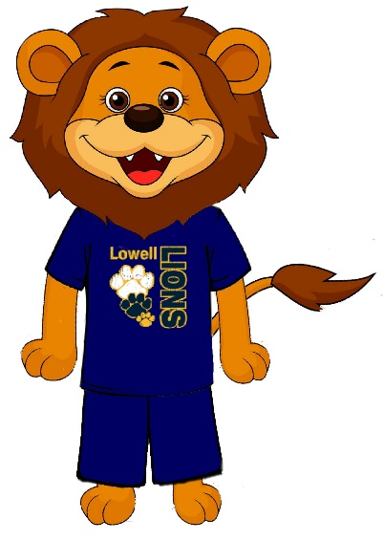

**Kindergarten**

S11 – Harlem Harmon

S12 – Sohalia Francois

S13 – Sarai Quattlebaum

S15 – Colin Robinson

**Life Skills**

S17 – Naim Shaw

**Autistic Support**

S19 – Gabriel Irizarry

**Emotional Support**

S21 – Rodney Lester

**First Grade**

S23 – Tyshawn Freeman

S24 – Sarhiya McArthur

S25 – Lynasia Im

S29 – Saya Srey

**Students of the Month**

**September 2022**

**Quality: Lion Pride**

**Second Grade**

107 – Julien Stewart

108 – Skylar Arnold

109 – Abdallah Howard

**Third Grade**

303 – Sa’miyah Revere

309 – Charae Dwyer

310 – Laylah Ortiz

**Fourth Grade**

203 – Terelle Small

206 – Anna Manotham

207 – Kenya Armstrong